Solution/Workaround:
The AMI modeling standard allows the model maker to use any combination of analog (i.e. – IBIS) and algorithmic (i.e. – AMI) techniques, in order to achieve the correct results. Altera IBIS-AMI models require the user to change both the analog model and the Ivod AMI parameter, in order to change the Tx buffer output drive strength. The user is responsible for making sure his selections match.
Example:
The following figure shows the result of running the Altera Stratix-5GX Tx AMI model (v. 0p5) through a simple ADS simulation, with default values selected (i.e. – the “…_100_4” analog model selected, and the Ivod parameter set to ‘4’).
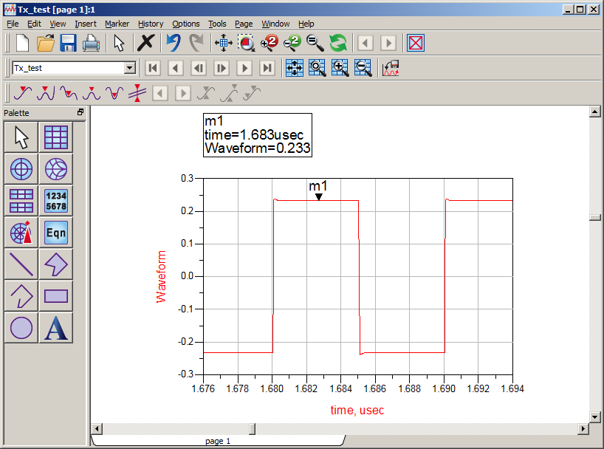
Now, just change Ivod to ‘5’ and re-run:
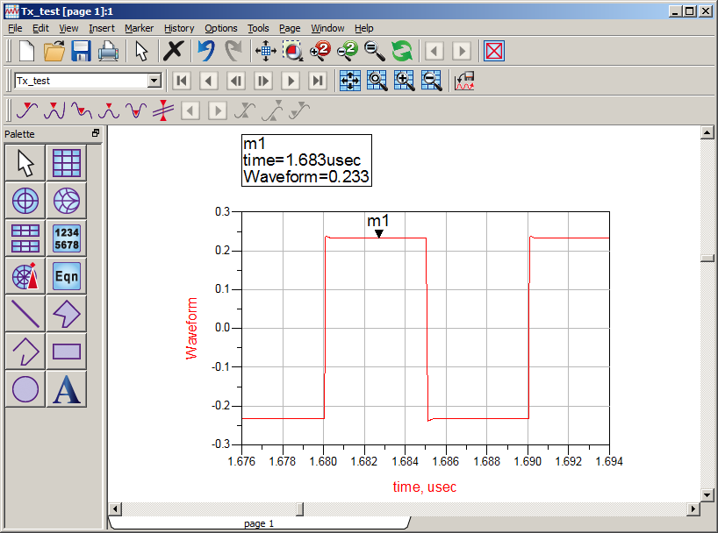
Note that there is no difference in the output level.
Now, also select the “…_100_5” analog IBIS model:
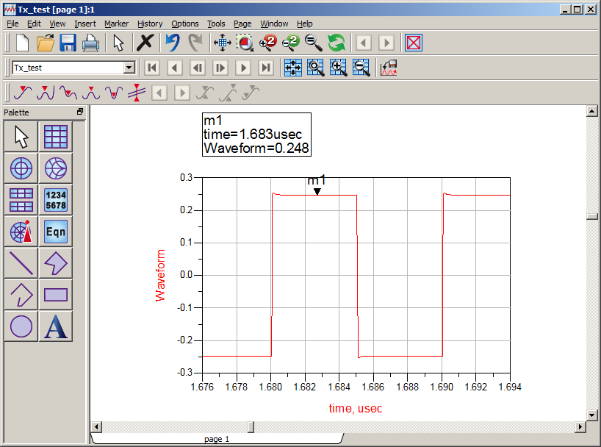
Note that, now, the output level has changed.
Prescription for customer:
Add the IBIS buffer to your simulation tool deck and ensure that you are selecting matching analog IBIS model and Ivod AMI parameter value.

